Importance of Ototoxicity Monitoring of Hearing Loss in Chemotherapy Patients

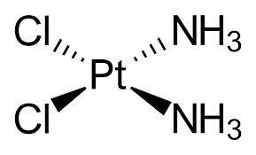
Many medications have the possibility of having ototoxic side effects. These drugs include platinum-based drugs, aminioglycosides, loop diuretics, and nonsteroidal anti-inflammatory drugs (NSAIDS); with the most ototoxic being Cisplatin. Since platinum-based drugs are used in cancer treatment regimens, it is important to have ototoxicity monitoring in place.

Ototoxcity monitoring has three primary functions. The first reason to refer a patient for a full audiological evaluation is to detect hearing loss. This evaluation should be completed using high frequency audiometry. Cisplatin has been seen to cause decreased hearing following the first administration; therefore, a baseline hearing test should be completed before treatment begins. Hearing should be monitored prior to each treatment as well as a few months following chemotherapy since these medications can have a delayed or progressive effect. If head and neck radiation has occurred, a hearing test should also be completed 1-2 years following completion.

The second part of ototoxicity monitoring is to document hearing and note changes. This information could help the oncologist choose a less ototoxic option although it is acknowledged that effective disease treatment is most important in these patients.

Finally, the third reason to have ototoxicity monitoring is for rehabilitation. If a hearing loss is present, it is important for the patient to hear doctors and family during this difficult time. Audiological rehabilitation includes counseling, communication strategies, amplification, and/or assistive listening devices.

Do you have any patients who are taking ototoxic medications?
Consider sending them to us for ototoxic monitoring.

American Academy of Audiology (Academy). (2009) Position Statement and Clinical Practice Guidelines: Ototoxicity Monitoring. https://audiologyweb.s3.amazonaws.com/migrated/OtoMonGuidelines.pdf_539974c40999c1.58842217.pdf
(accessed March 15, 2023).

