Hearing Loss and Cortical Neuroplasticity

Over there the past several years, research has shown there is a relationship between hearing loss and both structural and functional changes in the brain.

Anu Sharma, Ph.D. has conducted research studying neuroplasticity and cognitive function in individuals with hearing loss. Through EEG recordings, brain activity is measured following auditory stimulation. Results show “cross modal” cortical reorganization. When the area of the brain that normally processes sound does not receive proper input, the area of the brain responsible for vison and touch take over. Examples of such cortical reorganization are seen below with each image on the left representing normal hearing and each image on the right representing a hearing loss. As can be noted, different areas of the brain light up in response to auditory stimuli depending on whether or not there is a hearing loss. This cortical reorganization occurs even in cases of mild hearing loss.

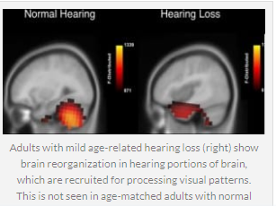
She theorizes that correction of this hearing loss either though hearing aids or cochlear implants may reverse cortical reorganization. Next month, we will show some evidence that correct amplification may reverse such changes in the brain.
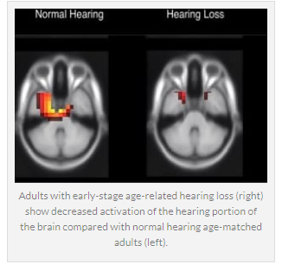

Do you have patients who only have mild signs of a hearing loss?
Consider sending them to us for an audiological evaluation.

Researchers Discover Brain Reorganizes After Hearing Loss. Hearing Review. May 2020.
Glick, H. and Sharma, A. Cortical Neuroplasticity and Cognitive Function in Early Stage. Mild – to – Moderate Hearing Loss: Evidence of Neurocognitive Benefit From Hearing Aid Use. Neuroscience (2020).

