Sudden Sensorineural Hearing Loss is a Medical Emergency!

In 2021, I (Bethaney Tessitore, Au.D.) experienced Sudden Sensorineural Hearing Loss (SSNHL). I conferred with an ENT who recommended I go directly to the ER and get a CT scan. At the ER, the physician didn’t understand the audiograms (my baseline and current from that day) and asked me if I went to a concert the night before. He told me that I didn’t need a CT scan and he was going to release me to see if my hearing and other otologic symptoms improved on their own. I requested he contact the ENT on call who reported that a CT scan was recommended. It was at that time that I began to understand that many physicians do not realize the importance of diagnosing SSNHL early.
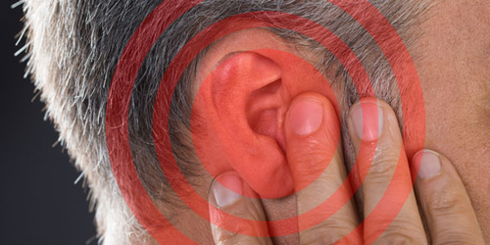
It is important to be able to recogize and identify SSNHL so that treatment can begin immediately! SSNHL is a rapid onset hearing loss that develops within hours or days (<72hours). It is frequently associated with ear fullness and Tinnitus. The prevalance of SSNHL is 5-27/100,000 and peaks in individuals between the ages of 50-60. More often than not, the hearing loss is unilateral.

SSNHL is due to damage within the cochlea of the inner ear or nerves. Suspected causes are vacular, viral infections, viral reactivation, otologic, traumatic, or neoplasm. This must be differentiated from a conductive hearing loss due to a pathology of the outer or middle ear. Ascertaining this will determine course of treatment.

SSNHL has a worse prognosis if vertigo occurs simultaneously, as well as if the patient is over 60 years old or under 15 year old. The prognosis is better if the hearing loss is low frequency, severe, and treatment begins early.

The rate of spontaneous recovery within two weeks is 46%. There are significantly better outcomes if steroid treatment begins within seven days of onset. Antivirals have not been found to be effective for idiopathic SSNHL. Hyperbaric oxygen (HBO) therapy has been used, with best results indicated for people who also experience Tinnitus alongside SSNHL. As with steroid therapy, best outcomes are shown when HBO is started within 14 days of onset.

Sudden sensorineural hearing loss is considered a medical emergency. Significantly better outcomes are seen when treatment is started early. It is imperative that these patients are seen in your office as soon as possible so a referral to an ENT can be made quickly and steroids can be started within seven days of onset.

Jung, W. W., & Hoegorl, C. (2022, January 19). Sudden Sensorineural Hearing Loss and Why It's and Emergency. PubMed. Retrieved March 28, 2023, from www.ncbi.nlm.nih.gov

