Genetic and Causal Effects of Age-Related Hearing Loss in US Adults

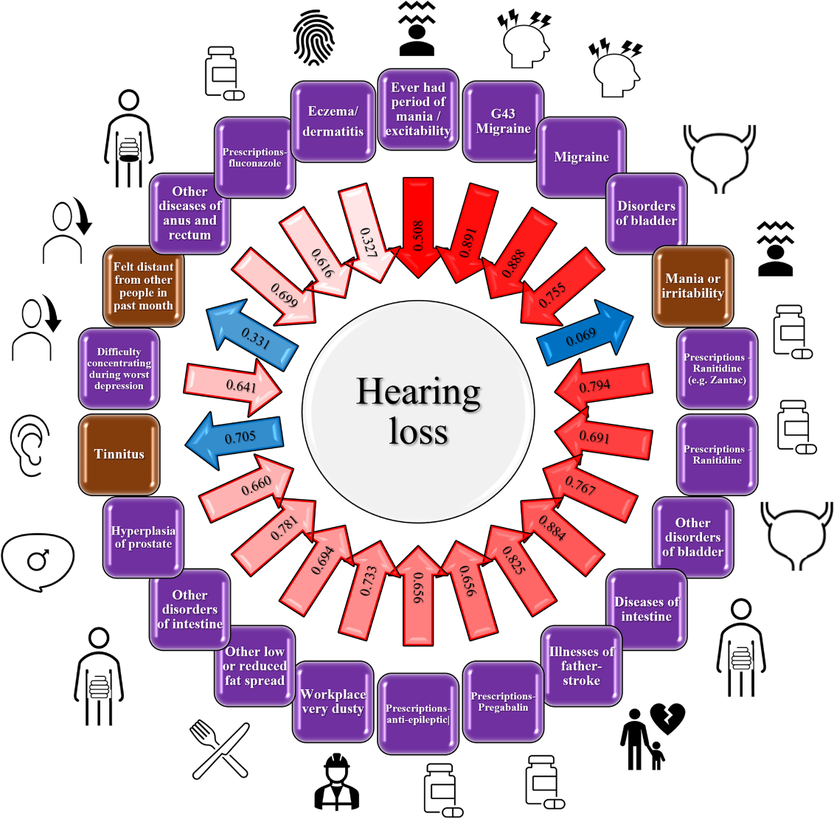
A 2023 study conducted by the Yale School of Medicine has found new insights on the genetic factors impacting hearing as we age. The authors found 54 risk loci and found a high polygenic risk is shared across ancestry groups. They also examined the causal effects identified through latent casual variable analysis- see more about these factors in their image below!
From the Study

Brown label: hearing problem has a causative effect on the trait in the label.

Purple label: trait has a causative effect on hearing problems.

Blue label: Hearing problem causes trait.

Red Label: trait causes hearing problem.

The shade intensity of the arrows is proportional to the statistical significance.

De Angelis, F., Zeleznik, O.A., Wendt, F.R. et al. Sex differences in the polygenic architecture of hearing problems in adults. Genome Med 15, 36 (2023). https://doi.org/10.1186/s13073-023-01186-3

Still Unknown- Why Men are More Likely to Have Hearing Loss with Age

From this study, they found that hearing loss is more prevalent and more severe in men compared to women, and the authors indicate a potential role of estrogen in our hearing function. While it is understood that men are more likely to have environmental risk factors, such as smoking, or occupational or recreational noise exposure, the molecular processes underlying these conditions are not completely understood.

Have patients with a family history of hearing loss or other factors listed above?
Consider sending them to us for an audiological evaluation.

