Hearing and Vestibular Consequences of Diabetes

It has long been postulated that Diabetes can have a negative impact on a person’s hearing and vestibular system. Although the mechanism of how this occurs is unknown, animal and human studies show an independent relationship between Diabetes and hearing loss. Some possible ways in which hearing loss may co-occur with Diabetes may involve microangiopathy, mitochondrial dysfunction, advanced glycation end products, inflammation, and glutamate excitotoxicity.

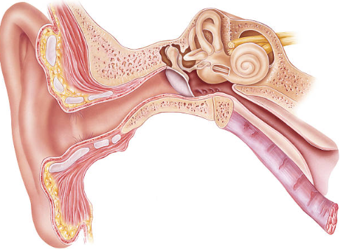
A recent study found hearing loss twice as common in people with Diabetes as those in the control group. Hearing loss may also present itself earlier in the life span as well as be adversely affected by comorbidities such as hypertension and cardiovascular disease.

Diabetes also puts individuals at risk for vestibular loss. Risk for vestibular damage becomes greater for people who have Diabetes for a longer period of time and those who have greater AIC levels. This greater vestibular risk increases an individual’s chance of falling by two-fold as well as putting individuals at increased risk for wrist and hip fractures.

Screening for both hearing loss and vestibular issues can be incorporated into a physician’s appointment. Hearing screenings can be done using both a physical method or by using the Audiological Screening Questions for Diabetes. To screen for vestibular issues, various balance screenings are available for use.

Due to the potential for hearing loss earlier in life and the negative communication effects of hearing loss, it is important to establish a baseline audiological evaluation and counsel patients regarding protection hearing.

Do you have patients who have recently been diagnosed with diabetes?
Consider sending them to us for a baseline audiological evaluation.
Piker, E., Spankovich, C., Romero, D., Memering, C., and Pierantoni, J. What You Need to Know about Heaing and Vestibular Consequences of Diabetes. Association of Diabetes Care and Education Specialists in Practice. (2020)

