Hearing Loss and Smoking

In 2021, the CDC reported that 28.3 million adults in the United States currently smoke cigarettes. While the conenction between smoking and cardiovascular disease, cancer, and other respiratory issues is well known, most smokers are unwarare that smoking is also linked to hearing loss.

Current smokers are 1.69 times as likely to have hearing loss as the non-smokers, regardless of age. When someone has hearing loss due to noise exposure, the hearing loss is further exacerbated by smoking. Even nonsmokers been found to have an increased chance of hearing loss if living with a smoker. Past studies have found an increased risk of hearing loss with the increase in amount of cigarettes used.

How does Smoking Impact the Auditory System?

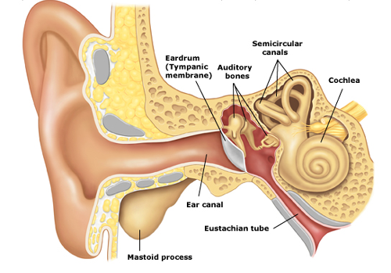
- Mucus Build-Up and The Eustachian Tube: As smoking increases, so does the amount of mucus produced in the lungs. It’s not surprising that this mucus can build up in the eustachian tube and lead to poor middle ear drainage.

- Inner Ear Oxygenation: The inner ear cochlea relies on consistent and high quality oxegenation to its steriacillia, and any change to the cardiovascular system can damage it. Both nicotine and carbon monoxide found in cigarettees can constrict blood vessels and limit the amount of quality oxygen reaching the inner ear. Increased blood pressure can damage the inner ear’s ability to detect sound.

In a recent study, researchers found smoking to be statistically associated with hearing impairment, with 66% of smokers in the study having a significant hearing loss bilaterally. The hearing loss most commonly found was sensorienrual in nature.

As hearing loss happens slowly over time, most people are unaware they have a problem until it is significantly impacting their quality of life. We recommend anyone who smokes to schedule a baseline hearing exam so that their hearing can be monitored long term.
Do you have a patient who is a long-time smoker?
Consider sending them to us for a baseline audiological evaluation.
Kumar, A., Singhal, S., Hasan, A., & Khan, A. (2013). The effect of smoking on the hearing status –a hospital based study. JOURNAL OF CLINICAL AND DIAGNOSTIC RESEARCH. https://doi.org/10.7860/jcdr/2013/4968.2730

